Content | Image
This year's Rabbit Awareness Week theme is 'Protect and Prevent' and will be raising awareness around Rabbit Viral Haemorrhagic Disease 2 (RVHD2).  RVHD2 is a new variant of the RVHD1 virus which causes internal bleeding.  The disease has a low recovery rate as there is no specific treatment for RVHD2 only supportive care.  Therefore, the best way to protect your rabbits is to vaccinate them!  For more information visit https://www.rabbitawarenessweek.co.uk/  #RAW2019 | 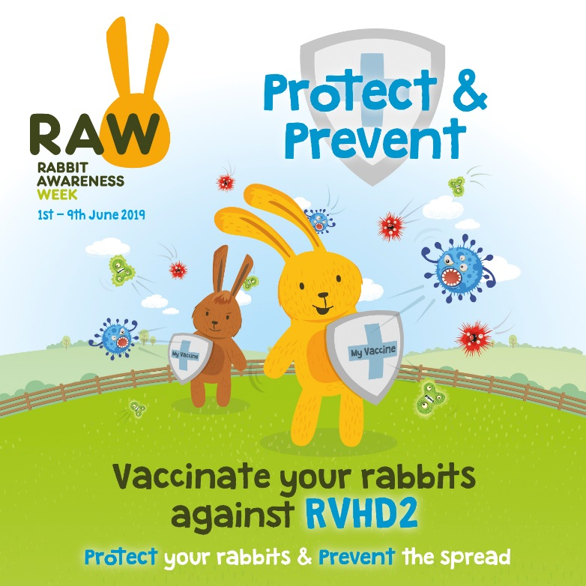
We’re happy to be taking part in RAW 2019 because we need to spread awareness that rabbits need to be vaccinated.  The latest figures show that less than 15% of Britain’s pet rabbit population is protected against RVHD2.  Why are the statistics so low?  According to the PDSA 2018 Paw Report the main reason for owners not vaccinating their rabbits was because they believed they never encounter other animals to obtain any diseases.  Unknown to them, this is not the only way your rabbit can become infected! Please visit https://www.rabbitawarenessweek.co.uk/  #RAW2019 | 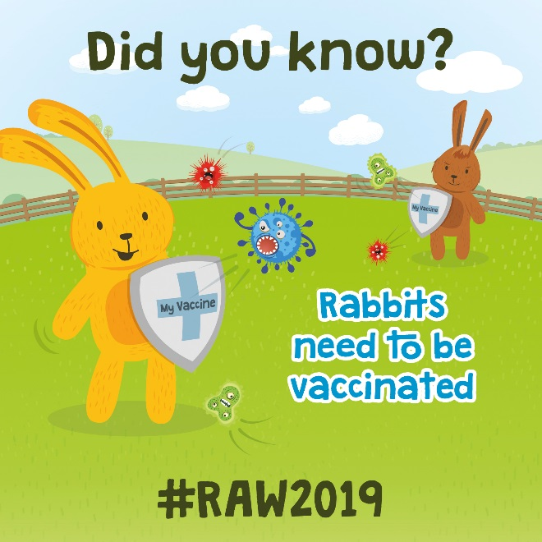
According to the PDSA 2018 Paw Report the main reason for owners not vaccinating their rabbits was because they believed they never encounter other animals to obtain any diseases.  Unknown to a lot of owners, this is not the only way your rabbit can catch the disease.  Here are some other examples:  - Birds and insects and their droppings  - The wind  - Soles of shoes, car tyres or other pets’ feet  - An infected rabbit or their droppings  - Owners’ hands or clothes  Don’t hesitate, vaccinate!  #RAW2019 | 